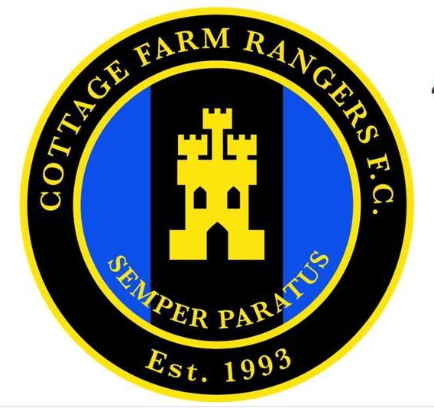
Code of conduct : Managers, Coaches & Club officials

We all have a responsibility to promote high standards of behaviour in the game. In the FA’s survey of 37,000 grassroots participants, behaviour was the biggest concern of the game. This included the abuse of match officials and the unacceptable behaviour of over competitive parents, spectators and coaches on the sideline. Play your part and observe the respect code in everything you do.

On and off the field I will:
- Show respect to others involved in the game including match officials, opposition players, coaches, managers, officials and spectators.
- Adhere to the laws and spirit of the game.
- Promote fair play and high standards of behaviour.
- Always respect the match official's decision.
- Never enter the field of play without the referee’s permission.
- Never engage in public criticism of the match officials.
- Never engage in, or tolerate, offensive, insulting or abusive language or behaviour.

When working with players I will:
- Place the well-being, safety and enjoyment of each player above everything, including winning.
- Explain exactly what I expect of the players and what they can expect from me.
- Ensure all parents/carers of all players under the age of 18 understand these expectations.
- Never engage or tolerate any forms of bullying.
- Develop mutual trust and respect with every player to build their self-esteem.
- Encourage each play to accept responsibility for their own behaviour and performance.
- Ensure all activities I organise are appropriate for the players ability level, age and maturity.

I understand if I do not follow the code the following actions may be taken where I may be:
- Required to meet with the club committee, league or county FA Welfare officer.
- Monitored by another coach.
- Required to attend an FA education course.
- Suspended by the club from attending matches.
- Suspended or fined by the county FA.
- Required to leave or be sacked by the club.

Name / signed:

Team name & age group:

Date:

